|  |
| --- |
| **National University of Computer and Emerging Sciences** |
| Lab Manual 1  “Introduction to MS SQL Server, Installation & Connection” |
|  |
| Database Systems Lab |
|  |

Department of Computer Science

FAST-NU, Lahore, Pakistan

# Objective

The purpose of this lab is to introduce students to Microsoft SQL server environment and getting started with installation and uses.

# Task Distribution

|  |  |
| --- | --- |
| Total Time | 170 Minutes |
| Exercise | 125 Minutes |
| Evaluation | 45 Minutes |

# Getting Started with Microsoft SQL server

In this section you will learn how to create open SQL server, connect with the database server, and create your new database (through design view and query as well).

## Step 1: Installation of SQL Server Management Studio

**SQL Server Management Studio (SSMS)**is an IDE that provides a graphical interface for connecting and working with MS SQL server. It was launched with Microsoft SQL Server 2005 and is used for configuring, managing, and administering all components within Microsoft SQL Server.

Following are the steps on how to download and install Microsoft SQL Server Management Studio (SSMS):

First of all you need to download SQL Server Management Studio (SSMS) installation files (SQLManagementStudio_x64_ENU.exe / SQLManagementStudio_x86_ENU.exe) from the [SQL Server download page](http://www.microsoft.com/en-us/download/details.aspx?id=29062) depending on your server type (x64,x86), and keep it in a separate folder.

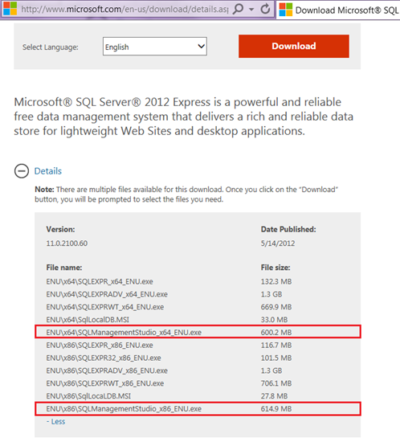`

**1:**Open explorer and you’ll see setup file as shown below.

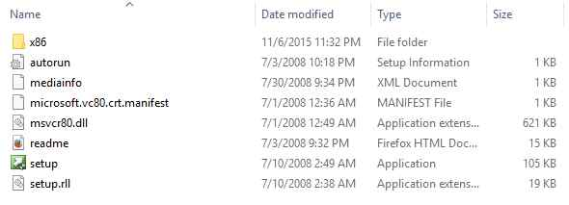

Right click on the setup and run it as Administrator.  
  
**2:**SQL Server Installation Center.

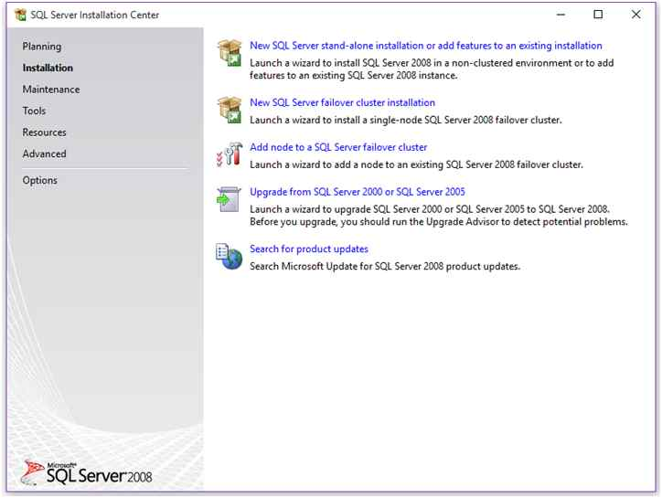

Go to installation section, here you’ll find various options to install instance, add new features and upgrade your SQL Server. As we’re doing a fresh installation, we’ll select first option i.e. “**New SQL Server stand-alone installation**”.  
  
**3:** Setup Support Rules

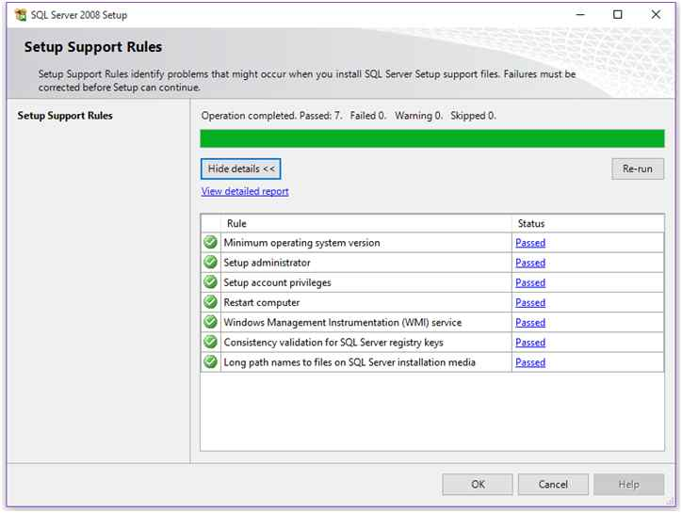

Here setup will perform a check to ensure whether you can proceed with the installation or not. If check fails on any step listed in the rules, you won’t be able to continue the installation.  
  
**Step 4:** Setup Support Files.

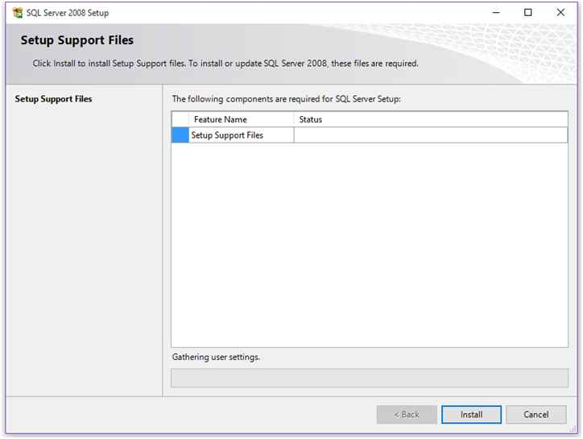

At this step SQL Server Setup look for some components required during installation. After successful check you’ll get Install button to proceed further. Click on Install Button.  
  
**Step 5:** Setup Support Rules.

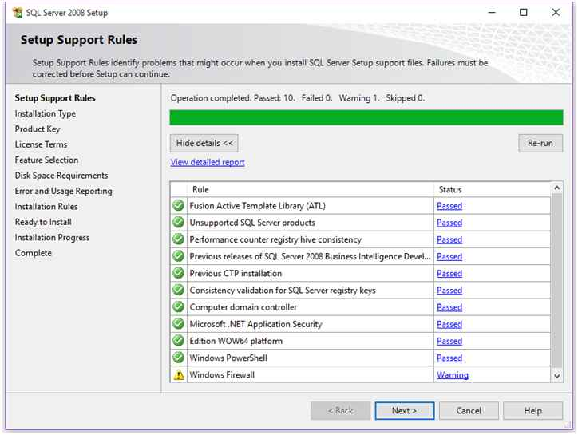

Again SQL Server runs a checkup after install to ensure whether your machine is OK or not for the installation. If you get passed in all rules, you’re good to go. Click Next.  
  
**Step 6:**Installation Type

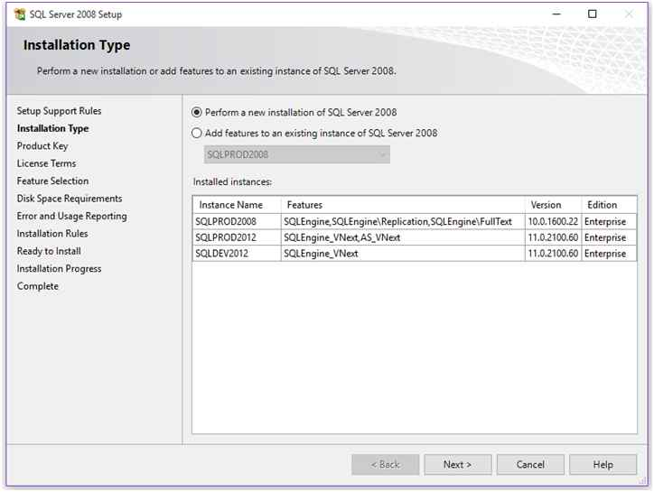

You find this step only if you previously installed any instances of SQL Server on your machine. At this step, you’ll find 2 options i.e.

* Perform a new Installation
* Add features to an existing instance.

As we want a new installation of default instance, we’ll select first option. If you want to add any additional features to your installed instance, you can go with option 2.  
  
Select option 1 and click Next.  
  
**Step 7:** Editions and Product Key

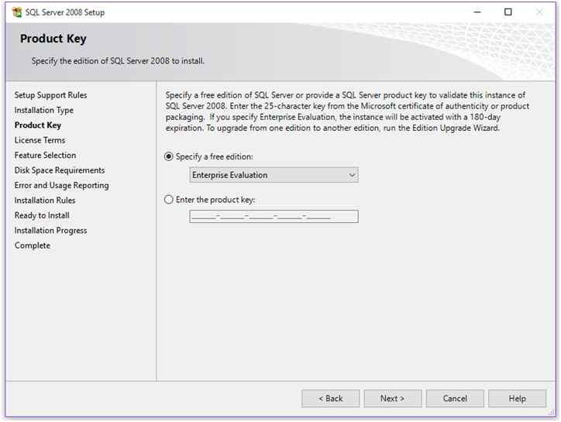

Here it’ll ask you the type of SQL Server edition you want to install on your machine or on server. If you want express edition, no need to specify Product Key. Other editions like Enterprise, Standard, etc. requires Product Key. Click Next  
 **Step 8:**License Term.

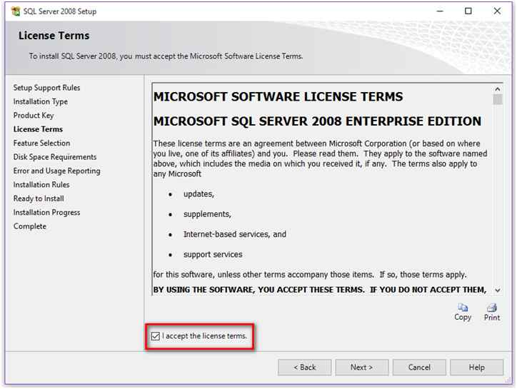

Click on “**I accept the license terms**” and click Next.  
  
**Step 9:** Feature Selection.  
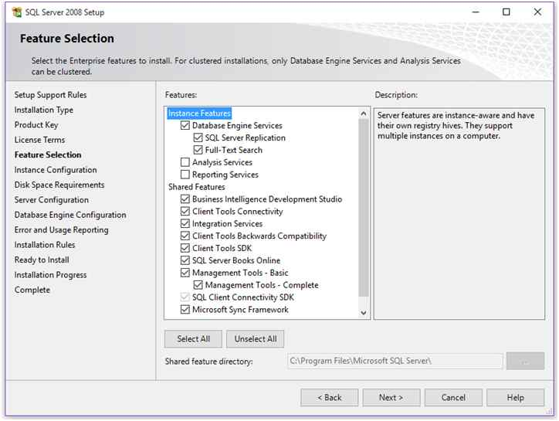

This is the important step during installation because at this step only you’ll select the features you want to install. As we don’t want Analysis and Reporting services now, we’ll not add these 2 components during installation process.  
  
Select “**Database Engine Services**” and shared features.  
  
Below you’ll find the path where these shared features will get installed.  
  
If you’re installing this on 64-bit machine, you’ll find 2 path boxes for shared features as shown below.  
 *Shared feature directory: To store 64-bit components.  
Shared Feature directory (x86): To store 32-bit components.*  
  
I’m using 32-bit machine hence I’m only getting 1 path box as shown in above image.  
  
Click Next.  
  
**Step 10:**Instance Configuration

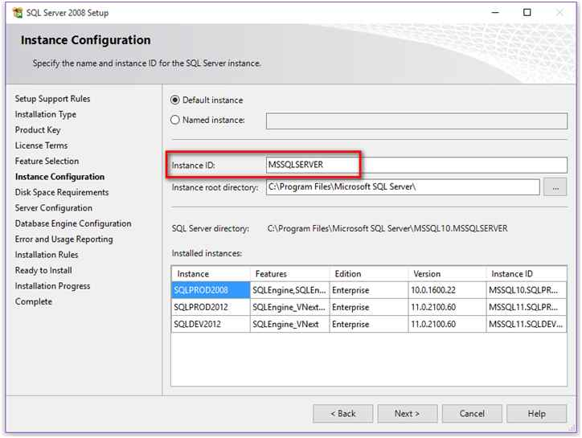

This is the step where you can specify what types of instance you want to install.  
  
To install default instance of SQL Server, select “**Default Instance**” otherwise select “**Named Instance**” type the instance name and specify the instance root directory.  
  
As we’re installing Default instance, we’ll go with first option and select Default instance.  
  
You can only install 1 default instance on a single machine. If default instance is already installed, you cannot select the “**Default Instance**” option.  
  
Click Next.  
  
**Step 11:** Disk Space Requirement.

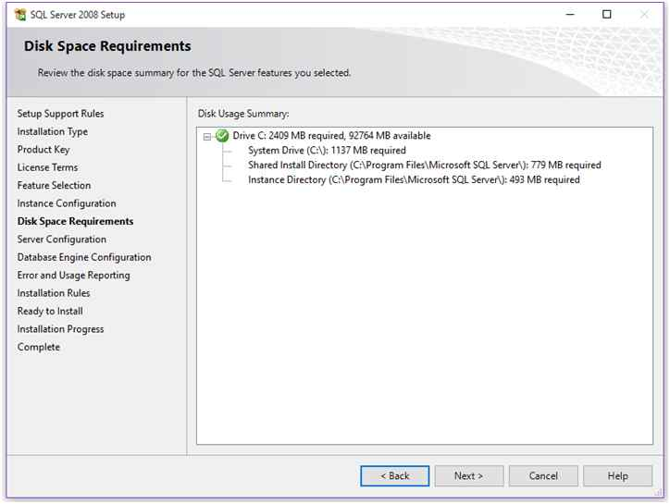

At this step, it’ll show you the required and available space on the drive you’re installing the instance.  
  
Click Next.  
  
**Step 12:** Server Configuration.

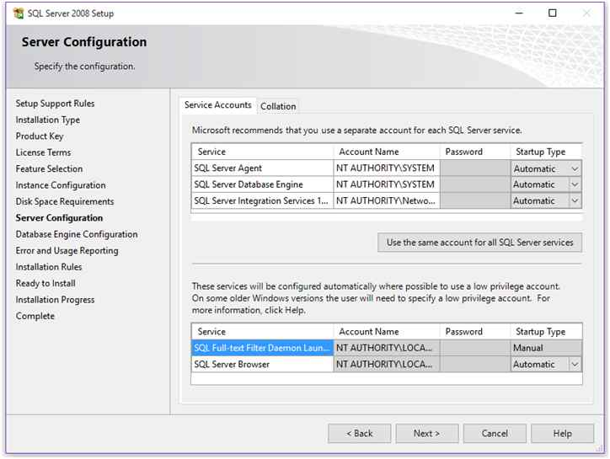

This step will determine how your SQL Services will run on your machine. Select the account name from which you want to run your services and select the startup type of the service.  
  
Click Next.  
  
**Step 13:** Database Engine Configuration

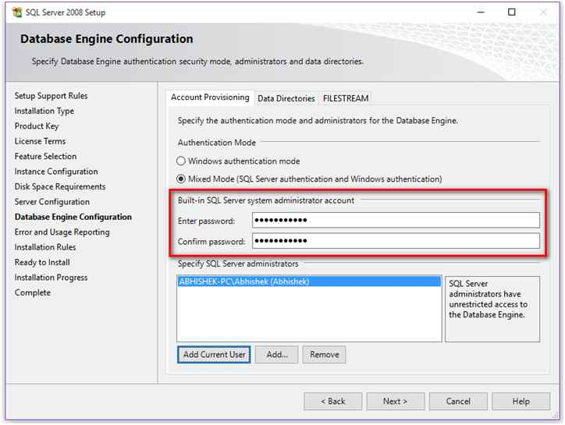

This is the 2nd most important step in installation process because here you’ll configure your database engine.  
  
Here you’ll find 3 tabs named  
  
Account Provisioning (Shown in above image):  
  
Here you’ll select your Authentication Mode and also you’ll setup your System Administration (SA) account.  
  
Select Authentication Mode as Mixed Mode and enter SA password. Add users as Sysadmin of the instance by using “**Add**” button. Add current user as SA admin by clicking “**Add Current User**”.  
  
**Data Directories:**

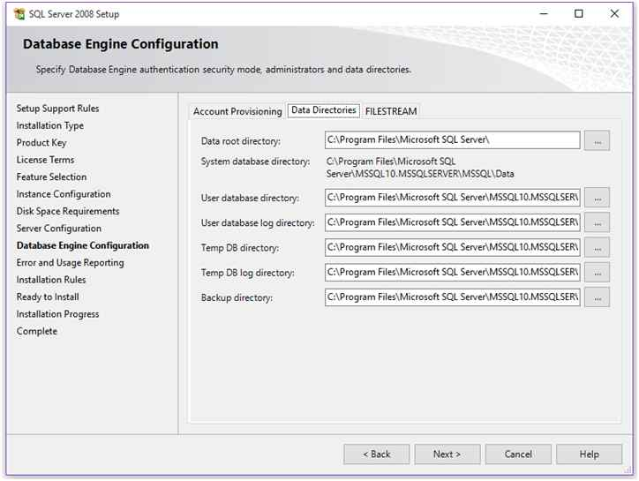

On this tab, you’ll get location of system databases, user databases, log file location, TEMP DB database location and also backup location. You can change these settings as per your choice.  
  
**File Stream**

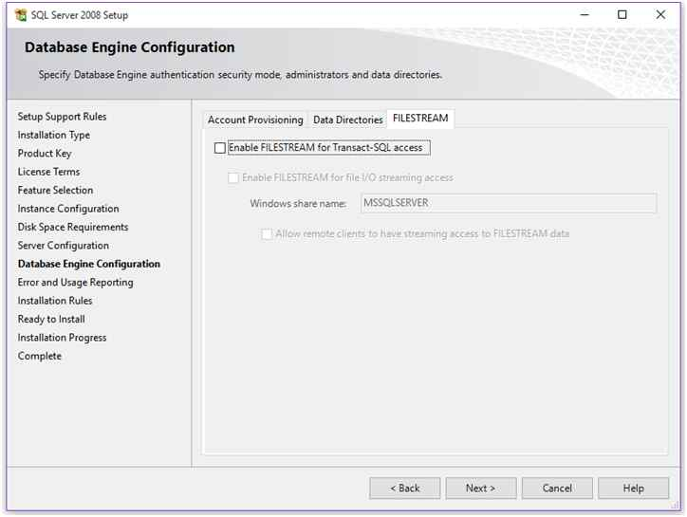

This tab will allow you to enable FileStream feature.

Click Next.  
 **Step 14:**Error and Usage Reporting

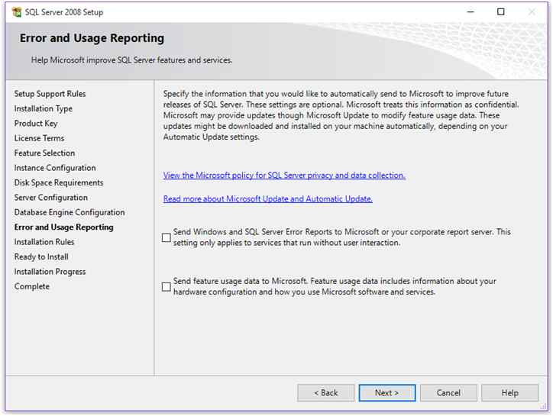

**Click Next.  
  
Step 15: Installation Rules**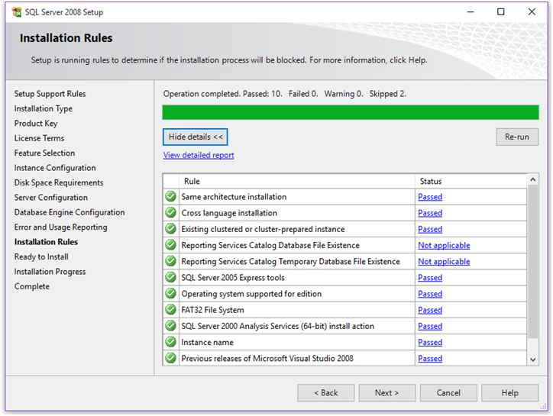

Setup will perform a check to ensure everything Ok to proceed further with installation. If all rule passes, click Next. **Step 16: Ready to Install**

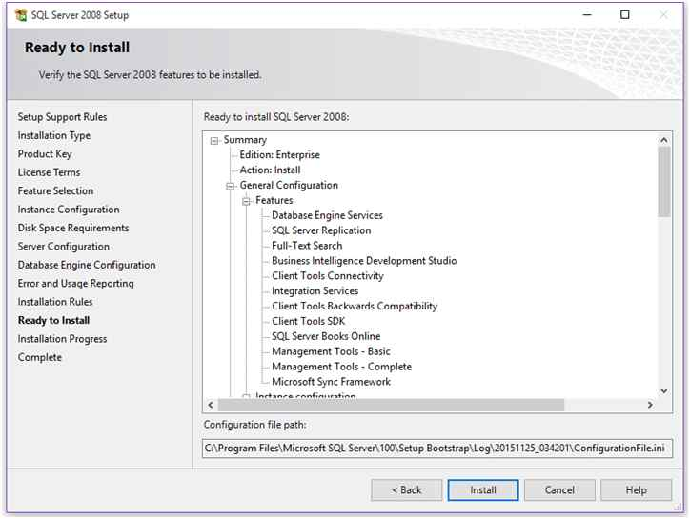

On this page, you’ll get the summary of the configuration options you’ve chosen. Click on Install button to start the installation process and track the progress as shown below.

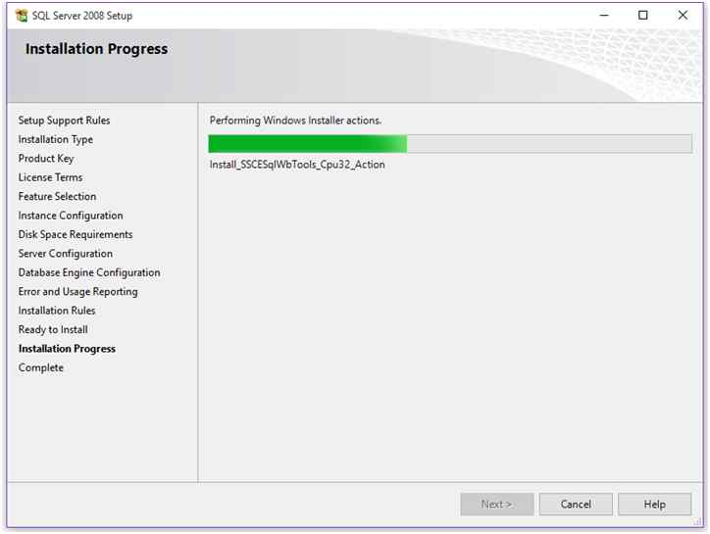

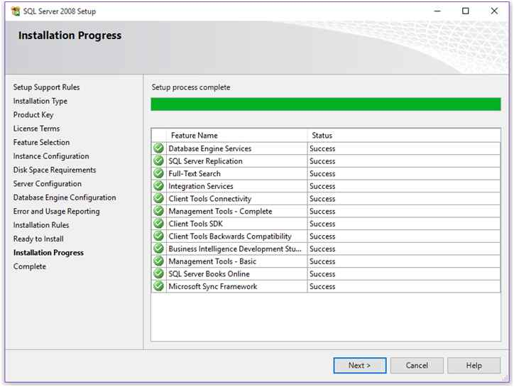

When setup finishes, you’ll get “Success” in status column of each installed components.  
  
**Step 17:**Installation completed

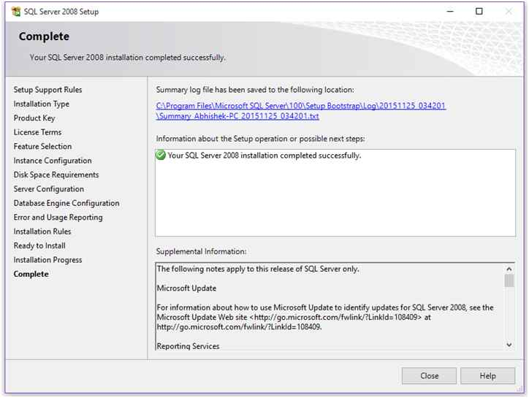

Your installation is completed and you’ll get a link of a log file of the installation to check if there are any problems. Click close to complete the installation process.

## Step 2: Open SQL server management Studio

Go to Start Menu and search for SQL Server Management Studio, open it

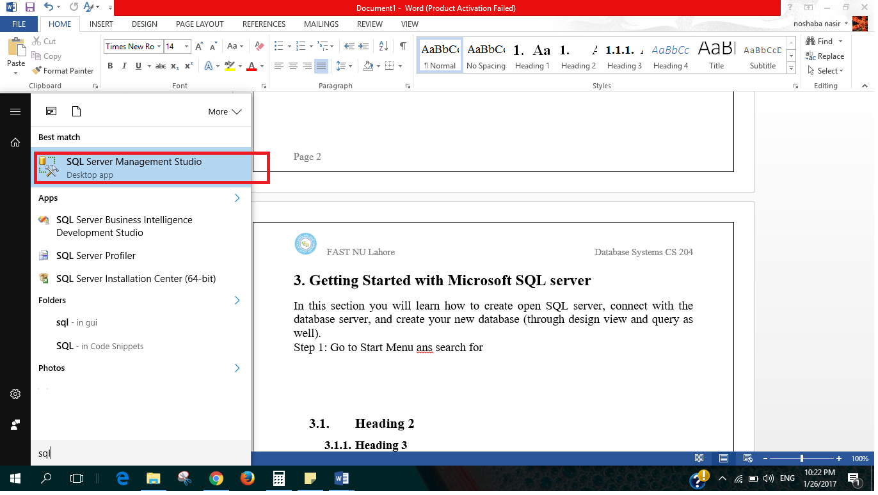

## Step 3: Connect to Server

One the left side you have object Explorer which you will use to explore all your databases and any object you create such as tables, on right there is Dynamic Help.

In the middle you can see Connect to server dialogue box.

Select SQL Server Authentication from Authentication Drop down

Ask for login and password from your lab instructor and press Connect

(refer to following figure)

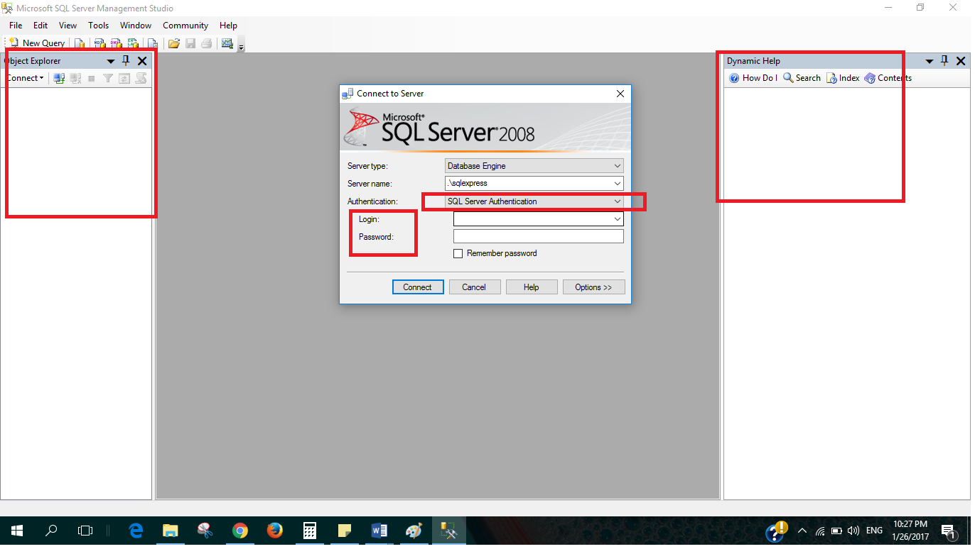

>>After this your SQL server is connected (as shown in following figure)

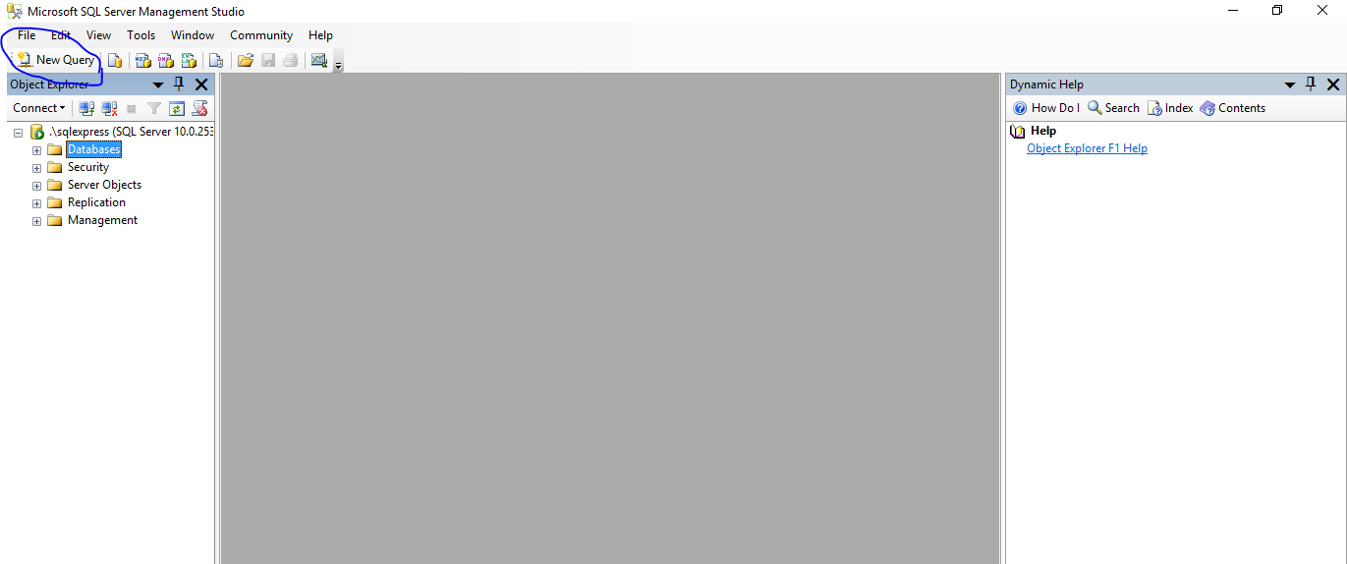

## Step 5: View and use your database

If you expand the Database from object explorer, you can see all of the databases that exist of the server, including the newly created ones (as shown in following figure).

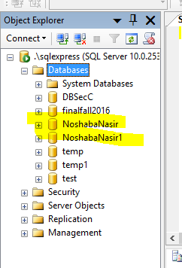

To use your database, make sure to select your database from drop down menu (as shown in following figure).

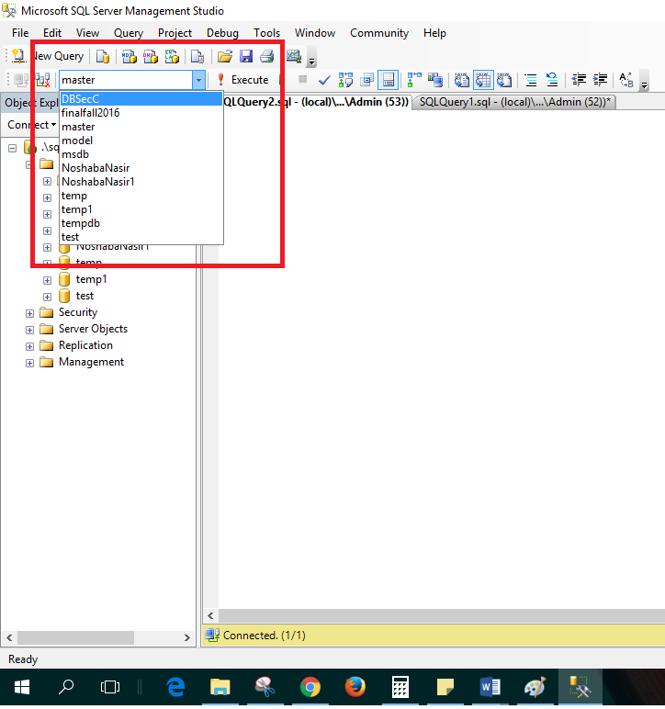

Or you can use the following query to use your database.

Use <databaseName>

## Data Types

